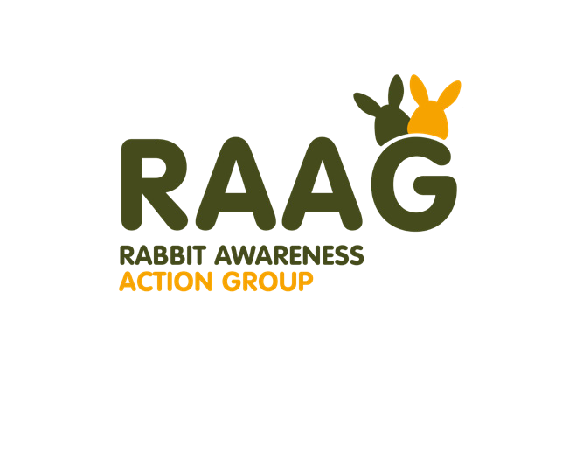

Rabbit Awareness Action Group (RAAG): who we are
RAAG is the trusted voice for rabbit welfare in the UK, bringing together the expertise of Burgess Pet Care, the RSPCA, the Rabbit Welfare Association & Fund (RWAF), Wood Green The Animals Charity and Blue Cross.
For the past 15 years, members of RAAG have campaigned through Rabbit Awareness Week (RAW) to help improve the lives of the UK’s pet rabbits, with impactful results1 including:
- A significant decrease in the number of rabbits living alone - from 67% in 2011 to 42% in 2020; and
- Fewer rabbits being fed muesli as one of their main food types – down from 49% in 2011 to 18% in 2020; and,

Our mission
RAAG recognises that although RAW has achieved a great deal, rabbits remain one of the UK’s most owned, but least understood animals, and should be high on the agenda year-round
- something echoed by the recent launch of the first Good Practice Code for the Welfare of Rabbits by UK government.
RAAG is committed to improving the lives of the UK’s pet rabbits by educating existing and prospective owners, and retailers, about the five key welfare needs of rabbits, comprising:
  - Environment: a hutch is not enough. Rabbits’ hutches should be a minimum enclosure size of 3m x 2m x 1m high. They should be able to stand up, lie stretched right out and hop at least three times.
  - Diet: move away from muesli, which can cause serious health problems. Rabbits should be fed at least their own body size in good quality hay each day, supplemented by a spoonful of nuggets and a handful of greens.
  - Behaviour: allow rabbits to exhibit their natural behaviours. Help rabbits to be the active, playful, inquisitive, and sociable animals they are.
  - Companionship: always keep your rabbits in pairs or groups. Rabbits are incredibly sociable animals and if they don’t have the right company and lots of fun things to do, they can suffer.
  - Health: the benefits of good diet and neutering. The most common health problems faced by rabbits come about simply because they are not given the right diet. Up to 80% of un-neutered female rabbits can develop cancer of the uterus by the age of five. Un-neutered males can be aggressive to other rabbits, yet neutered males can live happily with male and female rabbits.

How you can support RAAG
We are inviting all owners, and retailers, to join us in helping to raise awareness of the five key welfare needs of pet rabbits. By signing and/or sharing this letter you are showing your support in helping to meet rabbits’ needs, enabling them to live a life they deserve.
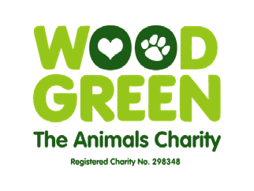
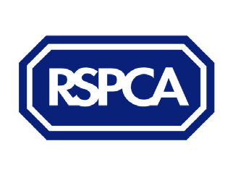
Signed:

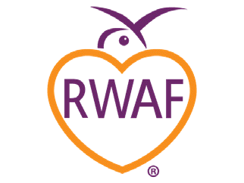
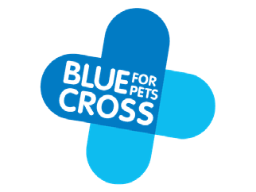
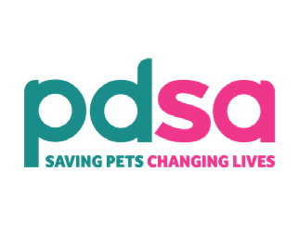
z

Sign the letter / Share the message

1 PDSA Animal Wellbeing (PAW) Report 2020, the largest and most comprehensive report into the UK’s pets.

